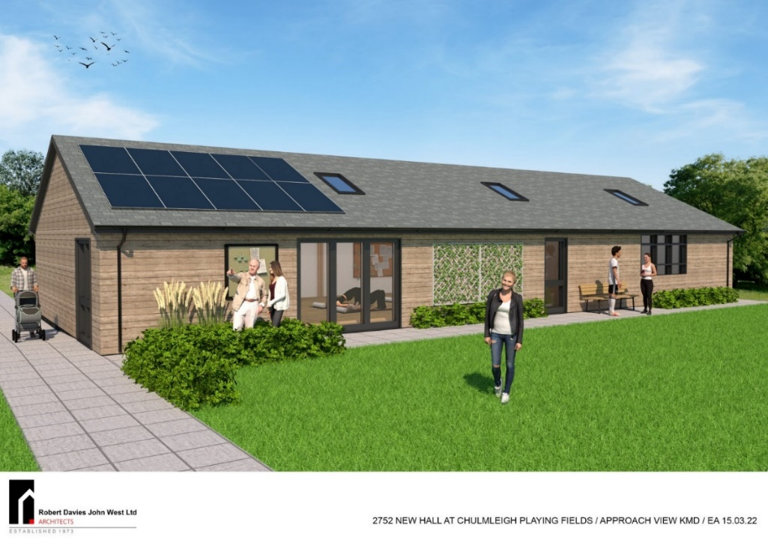

Construction is nearing completion of the first phase of the new hall of approx. 70 square meters. The eventual plan envisages extending the building to 160 square metres in Phase 2, as shown in the artist impression. Fund raising for that will commence once Phase 1 is up and running.

CPFA are delighted to report that we have secured the following grants:

**NORTH DEVON COUNCIL SECTION 106 FUNDING £80,000**

**THE BERNARD SUNLEY FOUNDATION £15,000**

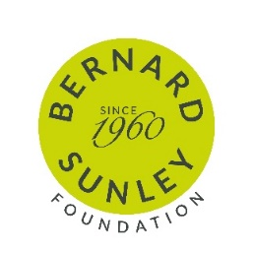

The Foundation was established in1960 by property developer Bernard Sunley. He was a pioneer in the post-war reconstruction of Britain and an entrepreneur in the legendary mould. A self-made man from modest origins, he was an individualist, a powerhouse of energy and ability and larger than life in every way. We were fortunate to have been successful with our application under their capital projects scheme which include new buildings, extensions, refurbishments and recreational spaces.

**THE GARFIELD WESTON FOUNDATION £20,000**

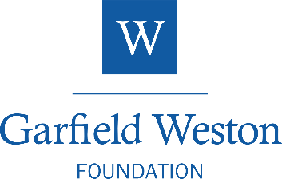Established in 1958, the Garfield Weston Foundation is a family-founded grant-maker that gives money to support a wide variety of charities across the UK. The Foundation’s funding comes from an endowment of shares in the Weston family business - a successful model that still exists today. The Weston family have a consistent aim. The more successful the family businesses, the more money the Foundation can donate.

Each Year the Foundation gives away its income and donations have continued to grow. Since it was established, it has donated over £1.5 billion of which over half has been given way in the past ten years. In the most recent financial year the Foundation gave away over £100 million to nearly 1,800 charities across the UK.

**RURAL ENGLAND PROSPERITY FUND £17,389**



**Delivered by North Devon Council**

Towards the cost of installing an Air Source Heat Pump, Underfloor Heating, PV Pannels and Battery Storage.

The UK Shared Prosperity Fund is a central pillar of the UK Government’s Levelling Up agenda and provides £2.6 billion of funding for local investment by March 2025. The Fund aims to improve pride in places and increase life chances across the UK by investing in communities, supporting local businesses, people and skills.

For more information, visit UK Shared Prosperity FUND: prospectus – GOV.UK ([www.gov.uk](http://www.gov.uk))

HMM 27.01.25

Chair: Kara Pincombe, Vice Chairman: Mike Hiscock,

Secretary: Howard Meadows, 07746 595287 howardmeadows77@yahoo.co.uk,

Treasurer: Andrea Summers, Facilities Manager: Andrew Mosedale