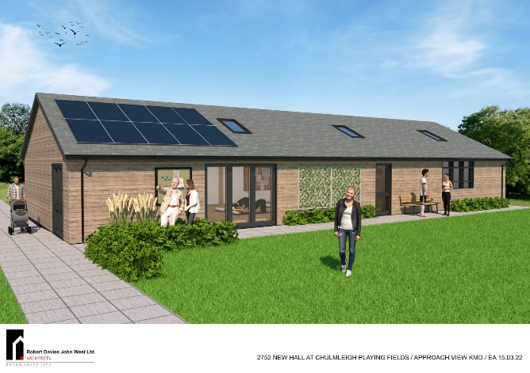NEWSLETTER

***NEW BUILDING***

Building started on Monday 8th July. Because of funding constraints, it will be in two phases. Phase 1 will be self-contained and about half the size of this artists impression. Please continue with your fundraising efforts.

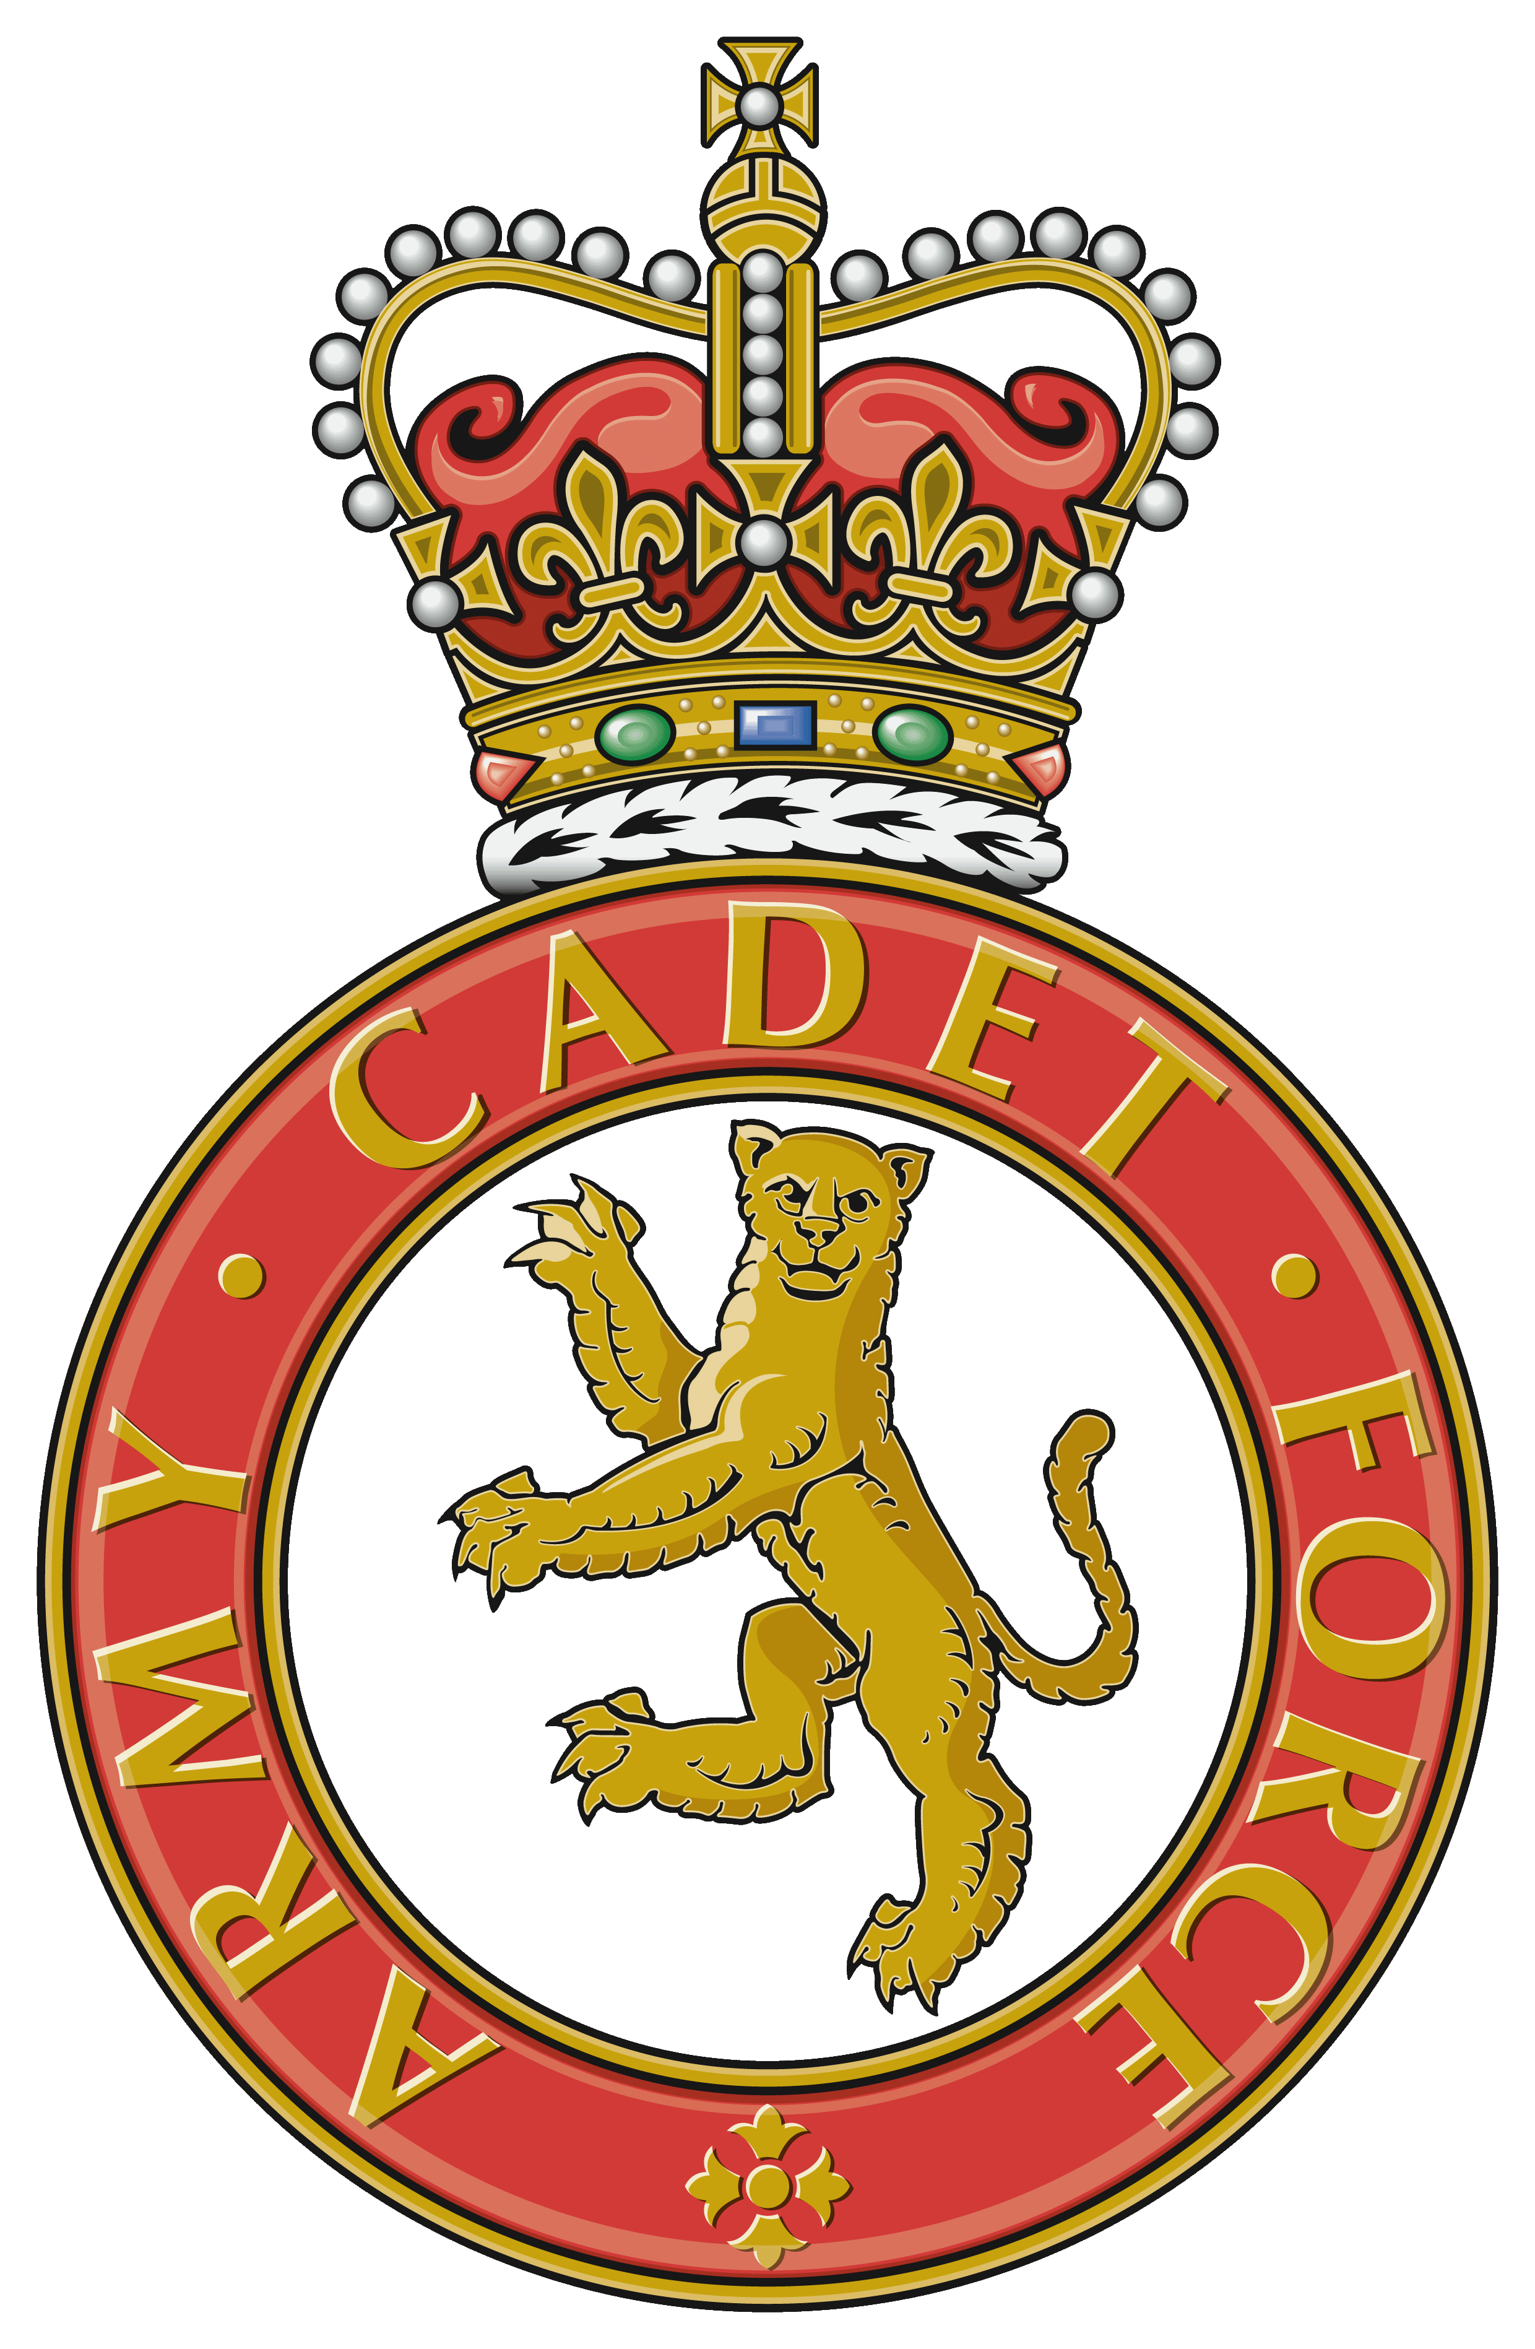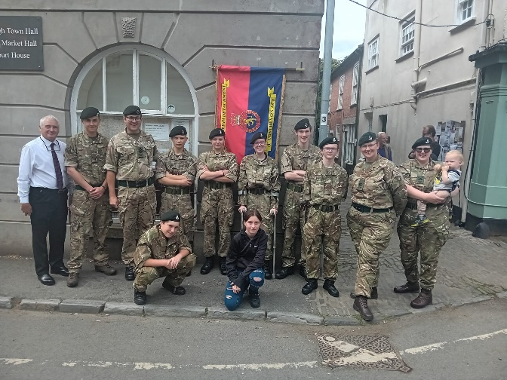

***ARMY CADET FORCE***

***CHULMLEIGH DETATCHMENT***

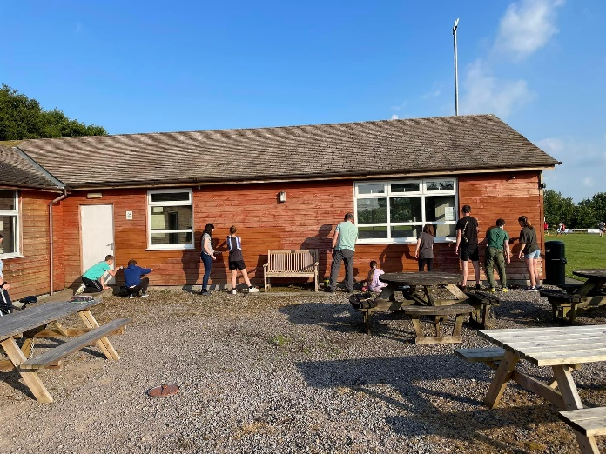

Congratulations to Chulmleigh Army Cadets for raising £333.45 towards the new building at a coffee morning in the Town Hall on Saturday 13th July, and for helping with painting the old Pavilion.

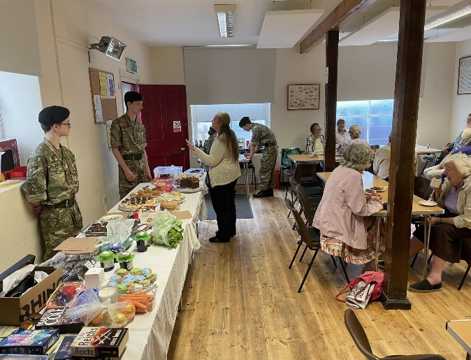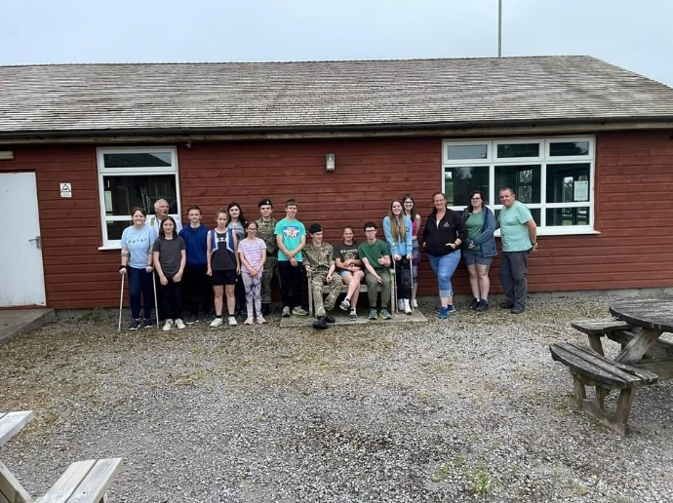

If you wish to know more about the activities at the Playing Fields, please visit [www.chulmleigh.org](http://www.chulmleigh.org) or contact either Andrew Mosedale or Howard Meadows.